1.Tablet (Android OS)
Step1： Go to "Google Play" and search “forticlient”, then install the APP.
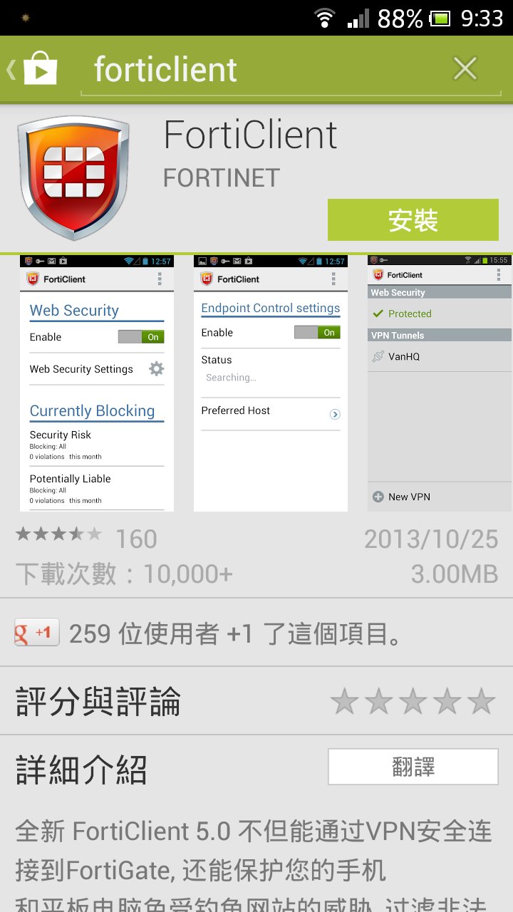

Click OK to continue.
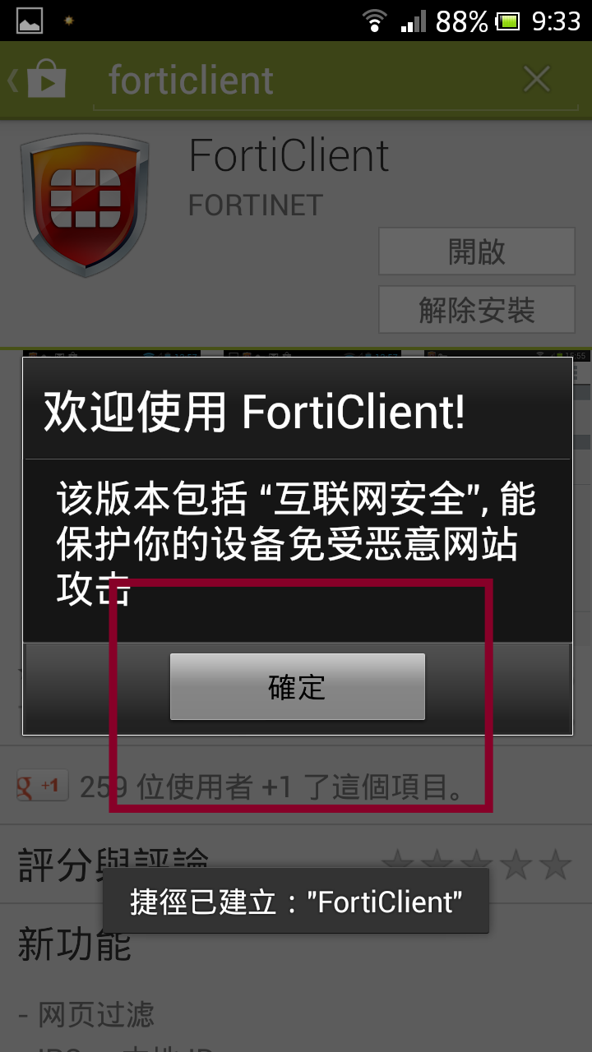

Click CANCEL to continue.
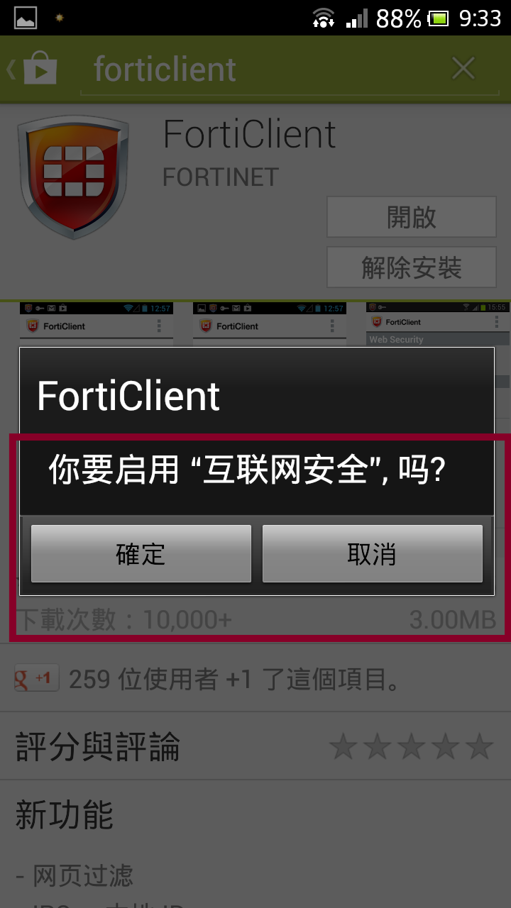

Click AGREE to continue.
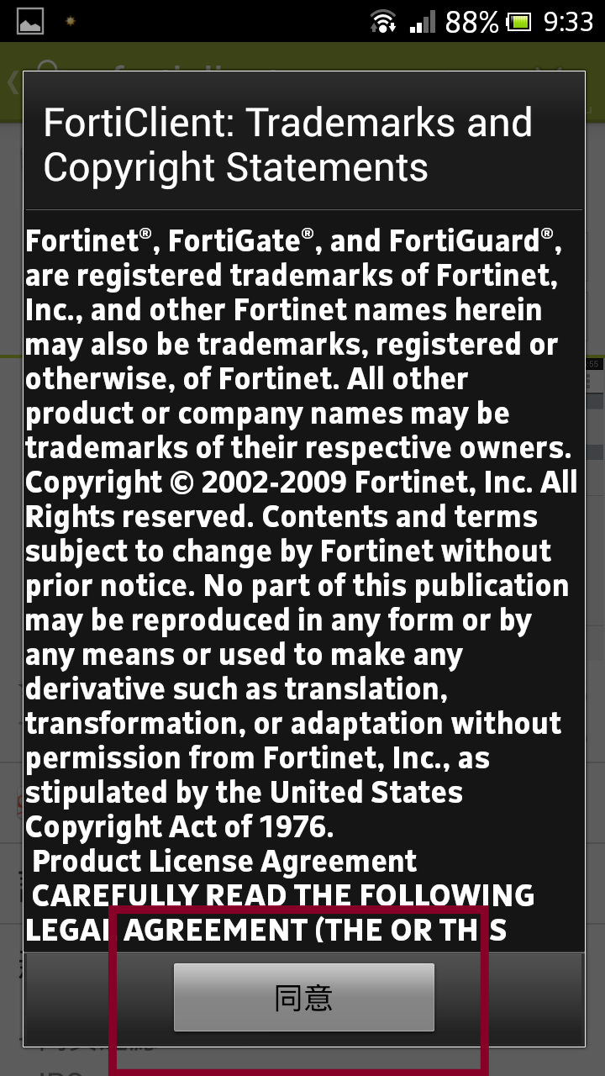

Step2： Type in VPN name (You can set up by yourself).Click SSL VPN and CREATE.
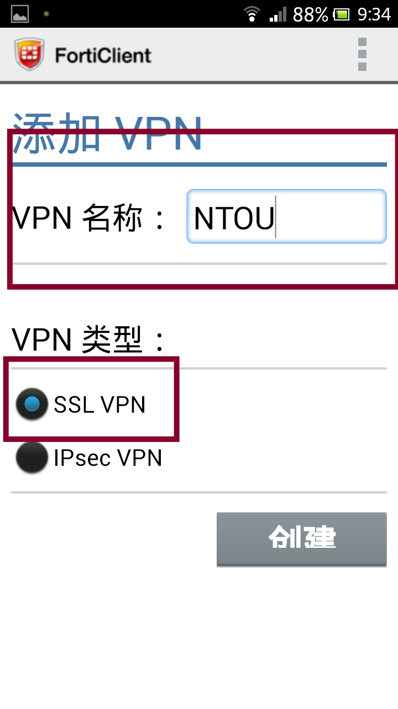

Step3：Type in Host Name 140.121.81.181. Type in User Name and Password, which are your email ID in NTOU.

Type IP 140.121.81.181
Acount E-mail acount
Password E-mail password
Back pre page and connect.
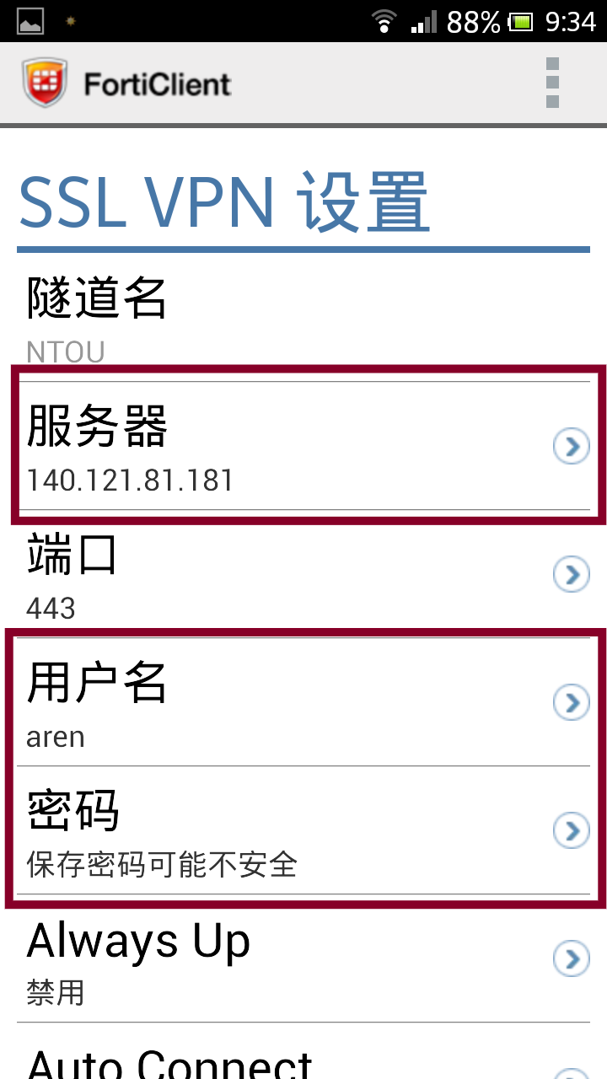
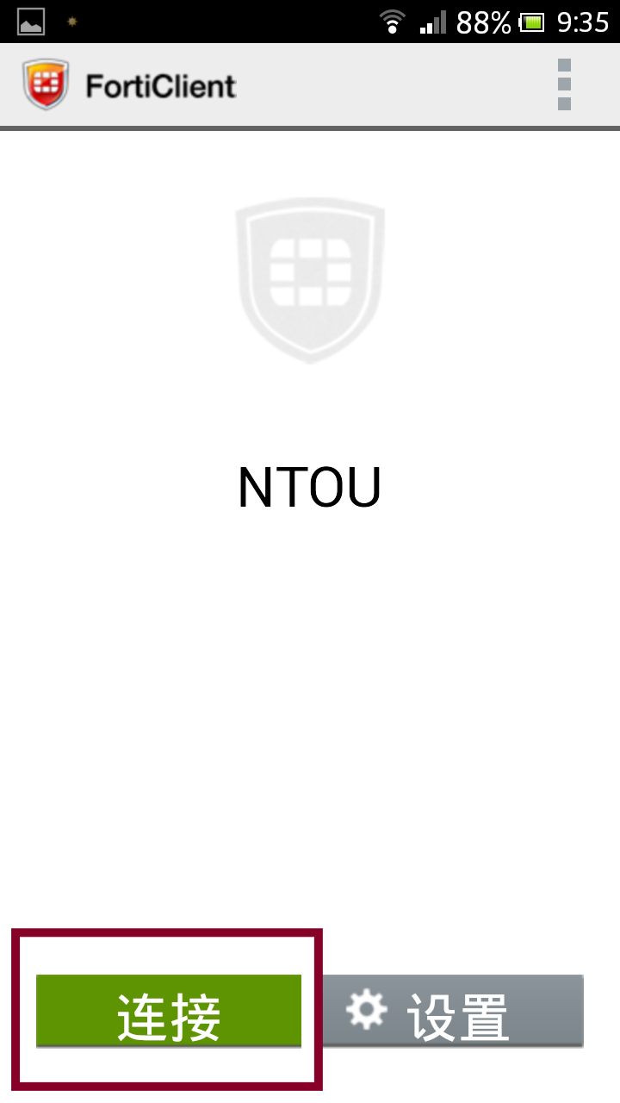
Step4：Setup complete！ Connect

Step5：Connect success! If you finish the process, click Disconncet
